TITLE

Simple water level indicator

**Submitted to**

Maksuda Khatun,

Sr. Lecturer of CSE, EUB

**Submitted by**

Lelin Chakma (200121044)  
Habibur Rahman (200121032)

**Project Overview**

This project will design and build a simple water level indicator circuit on a breadboard. The circuit will use a transistor, LEDs, and a buzzer to indicate the water level in a tank.

**Project Goals**

The goals of this project are to:

* Learn how to design and build a simple electronic circuit
* Understand the principles of water level sensing
* Create a functional water level indicator that can be used to monitor the water level in a tank

**Project Components**

The following components will be used in this project:

* Breadboard
* Transistor (BC547)
* LEDs (red, white, green)
* Resistors (330 ohms)
* Buzzer
* 9V battery

**Project Procedure**

The following steps will be used to build the water level indicator circuit:

1. Connect the transistor, LEDs, and resistors to the breadboard according to the circuit diagram.
2. Connect the buzzer to the positive terminal of the 9V battery and the negative terminal of the battery to the ground rail on the breadboard.
3. Fill the tank with water and observe the behavior of the LEDs and buzzer.

**Project Timeline**

The project is expected to take 1-2 weeks to complete.

**Project Circuit Diagram**

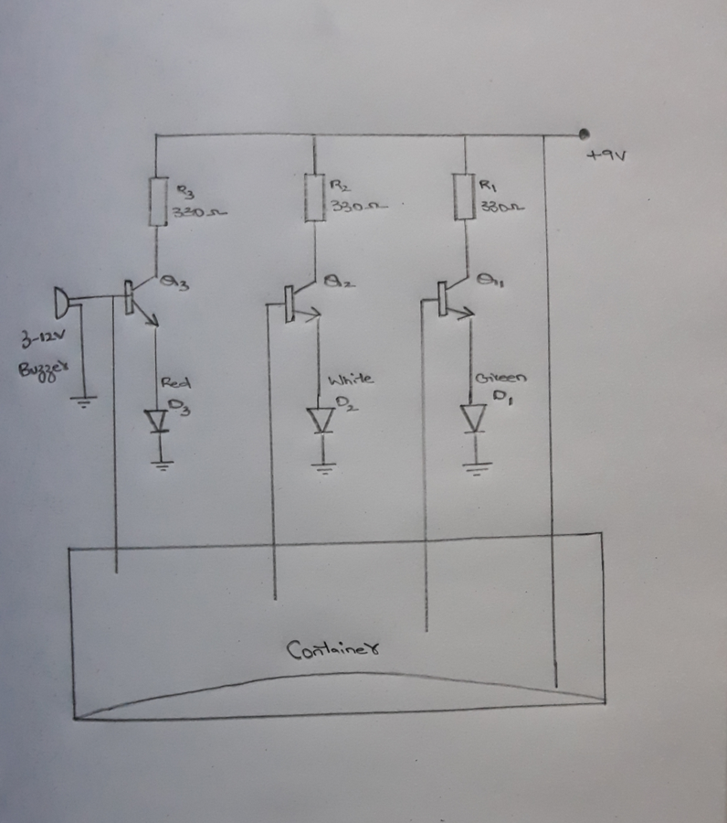

**Project Conclusion**

This project will provide the opportunity to learn about electronic circuits, water level sensing, and the design and construction of simple electronic devices. The project is expected to be completed within the specified timeline and budget.

Thank you for considering our proposal. We are available to discuss this project further and address any inquiries you may have.

Sincerely,

Lelin Chakma (200121044)

Habibur Rahman (190121003)